# Smart Farmer-IOT Enabled Smart Farming Application

**Project Development Phase**

# Sprint Delivery -2

|  |  |
| --- | --- |
| **Date** | 14 November 2022 |
| **Team ID** | PNT2022TMID48844 |
| **Project Name** | Smart Farmer-IOT Enabled Smart Farming Application |
| **Leader Name** | Babu kanna B |
| **Team Members Name** | Devarajan S M  Ajith R  Naveen kumar G  Tamilarasan M |

**Software:**

1. **Create device in the iot watson platform:**

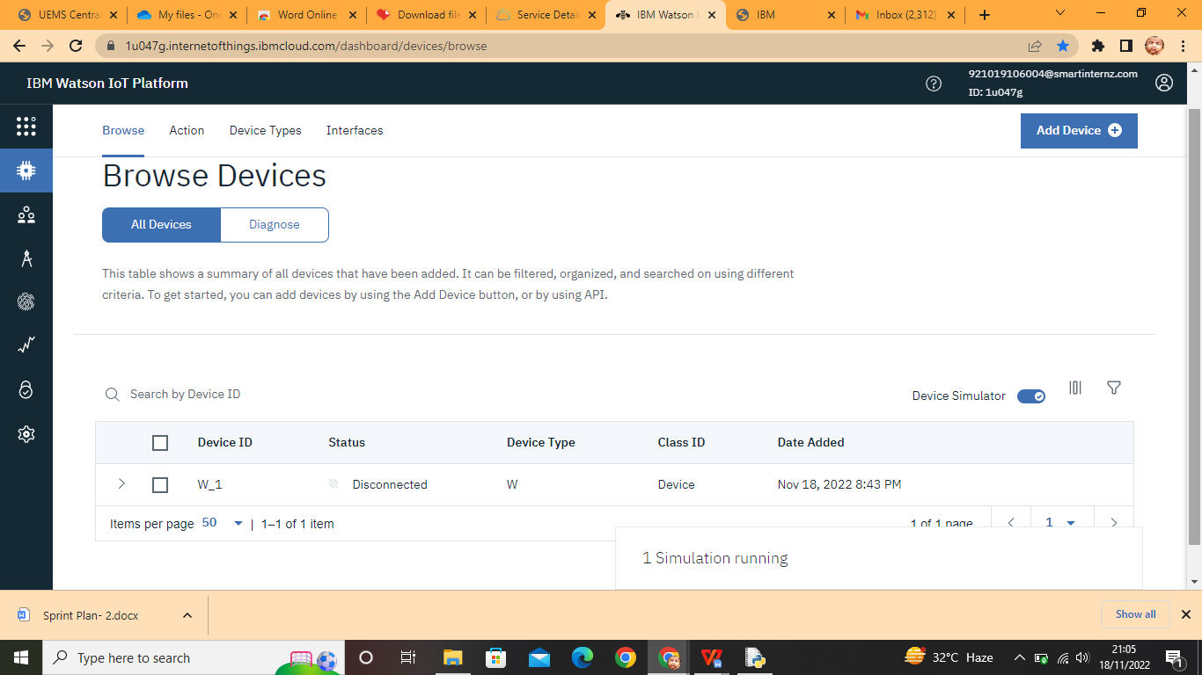

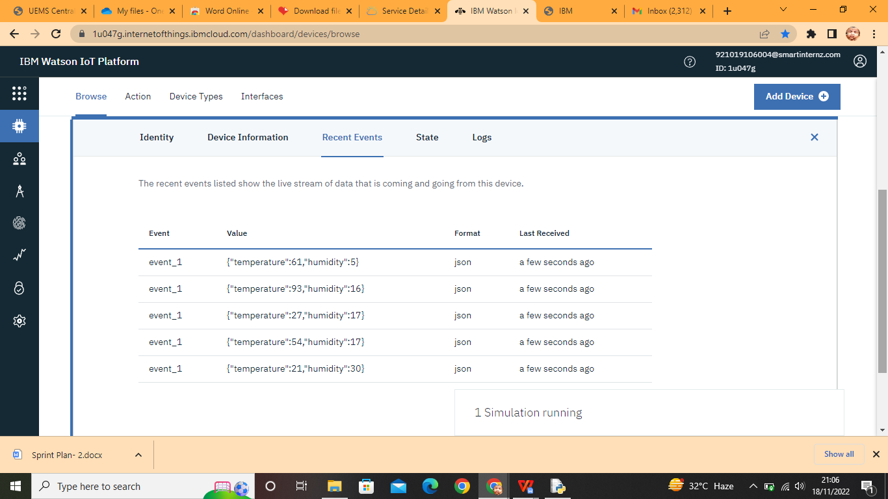

1. **Workflow for iot scenarios using local node red:**

